**Blurring/Smoothing**

Image for post

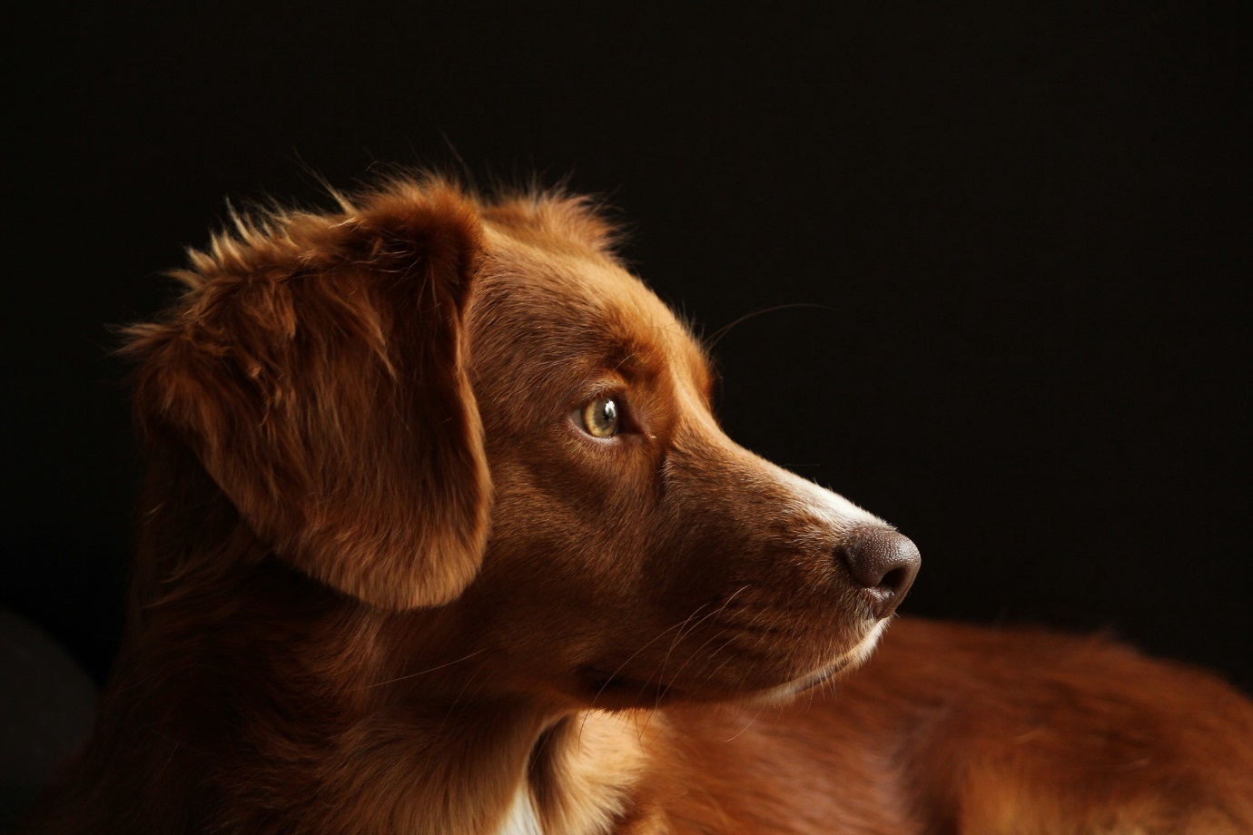

Image for post

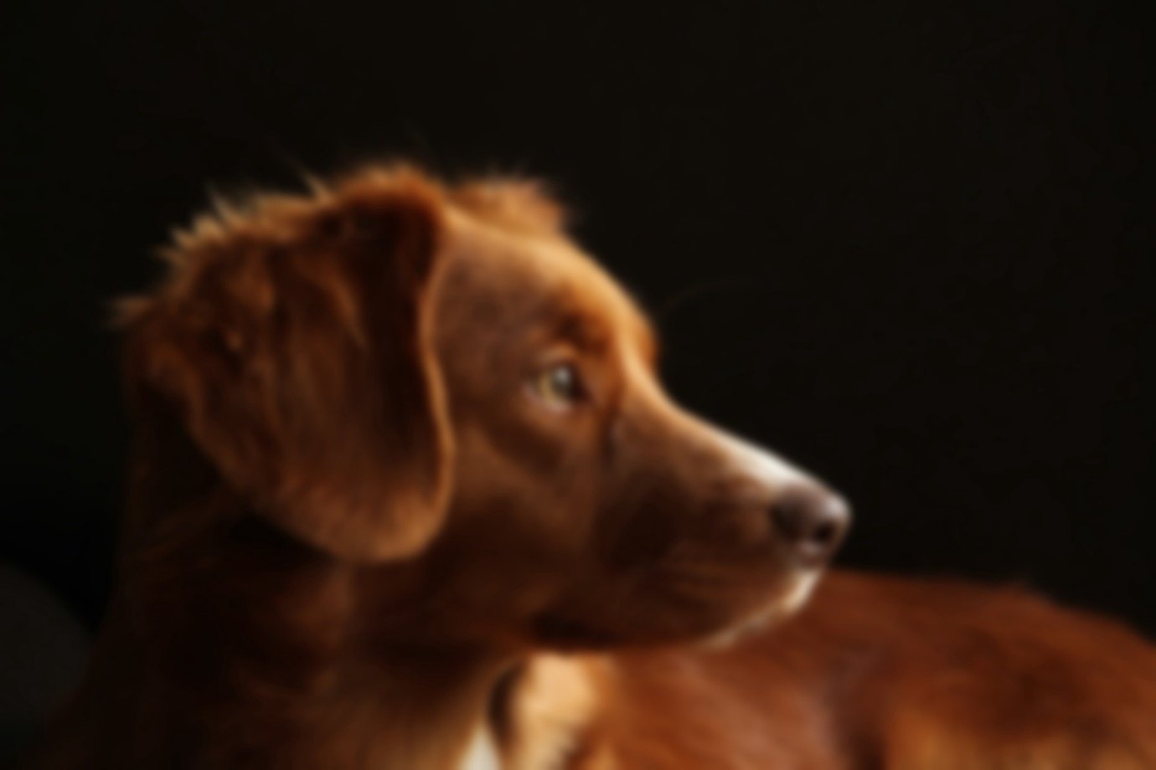

Left: Image from Pixabay. Right: Blurred doggo.

import cv2  
blurred = cv2.GaussianBlur(image, (51, 51), 0)  
viewImage(blurred, "Blurred doggo")

**The GaussianBlur function takes 3 parameters:**

* The first parameter is the image you want to blur.
* The second parameter must be a tuple of **2 positive odd numbers**. When they increase, the blur effect increases.
* The third parameter is The *sigmaX* and *sigmaY*. When left at 0, they’re automatically calculated from the kernel size.

*More blurring functions* [*here*](https://docs.opencv.org/3.1.0/d4/d13/tutorial_py_filtering.html)*.*

**Drawing a Rectangle/Bounding Box on an Image**

Image for post

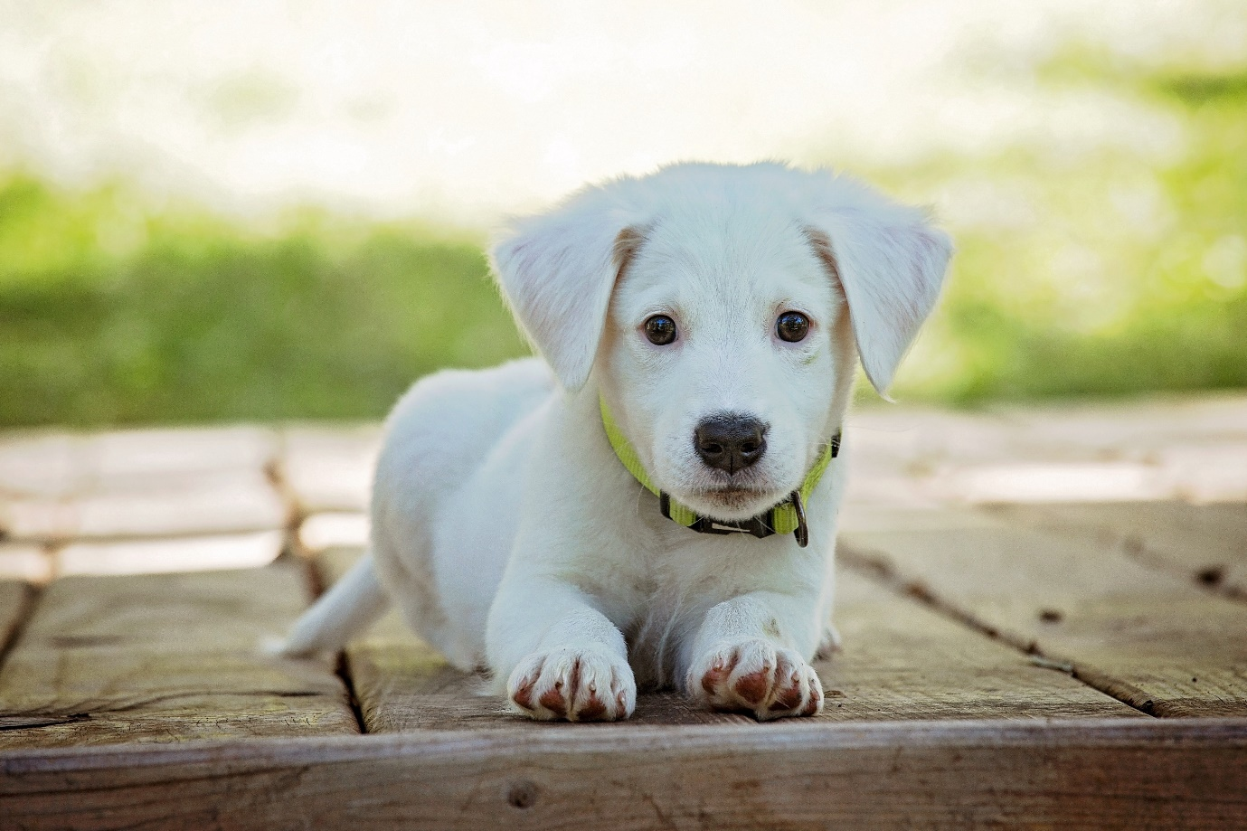

Image for post

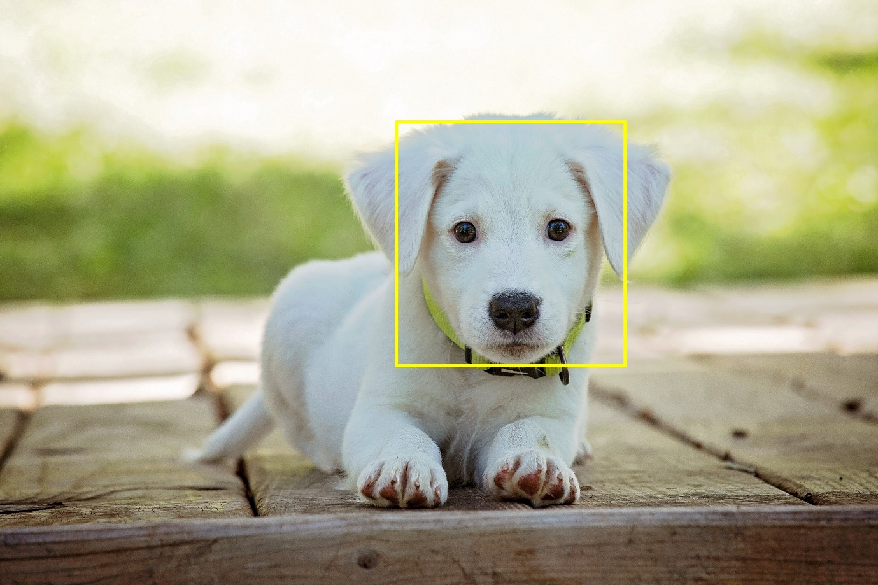

Left: Image from Pexels. Right: Doggo with a rectangle on his face.

import cv2  
output = image.copy()  
cv2.rectangle(output, (2600, 800), (4100, 2400), (0, 255, 255), 10)  
viewImage(output, "Doggo with a rectangle on his face")

**The rectangle function takes 5 parameters:**

* The first parameter is the image.
* The second parameter is *x1*, *y1 — Top Left Corner.*
* The third parameter is *x2*, *y2 — Bottom Right Corner.*
* The fourth parameter is the rectangle color (***GBR***/***RGB***, depending on how you imported your image).
* The fifth parameter is the rectangle line thickness.

**Drawing a line**

Image for post

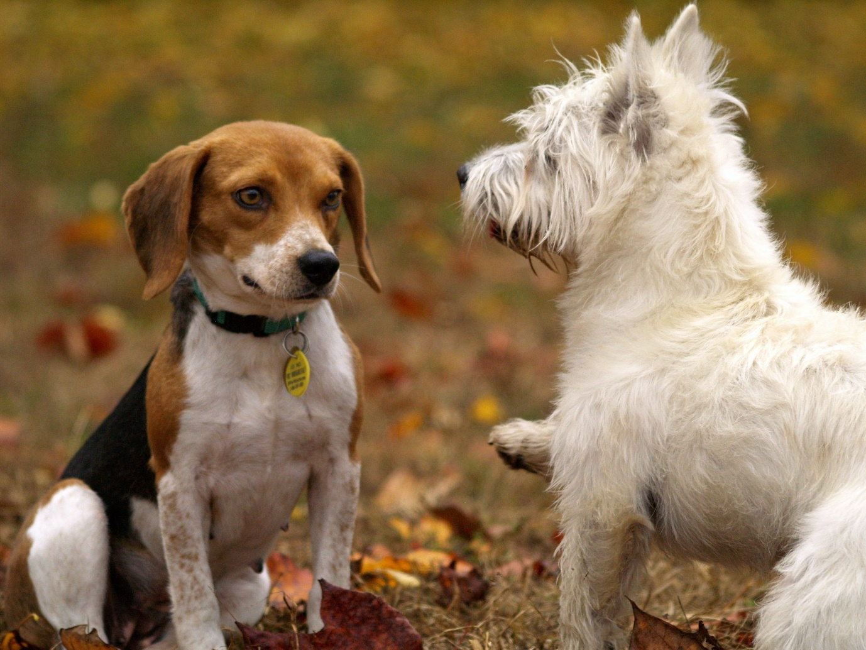

Image for post

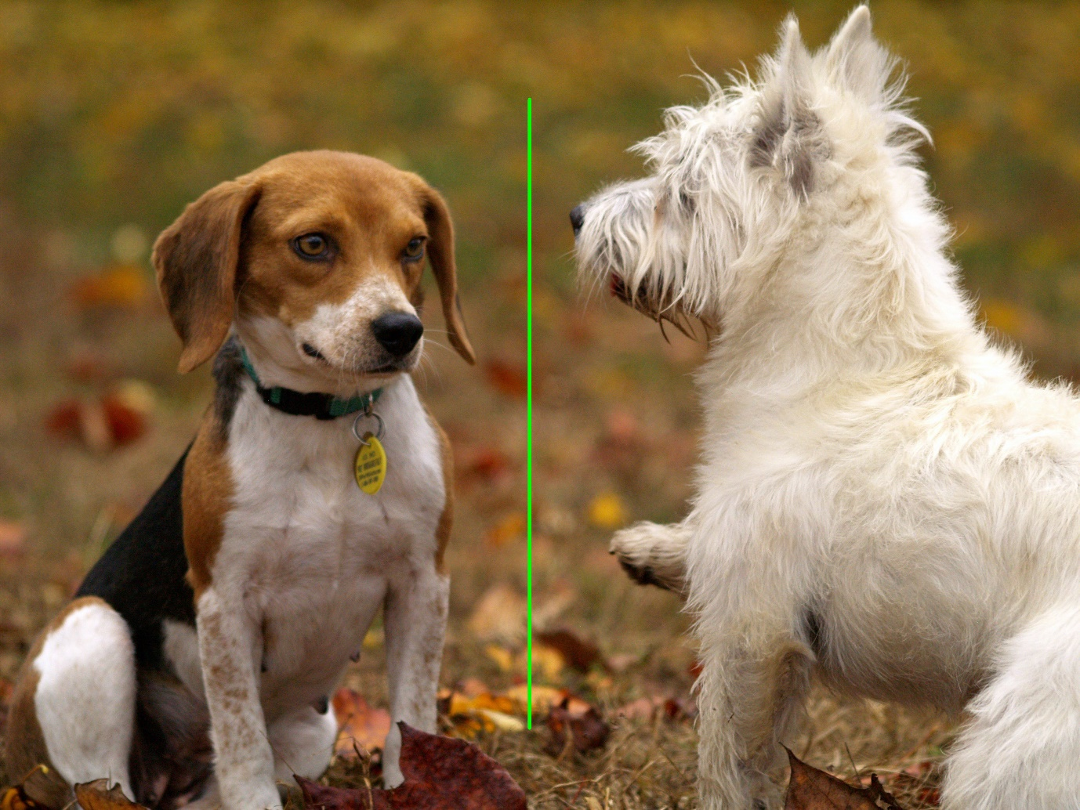

Left: Image from Pexels. Right: 2 Doggos separated by a line.

import cv2  
output = image.copy()  
cv2.line(output, (60, 20), (400, 200), (0, 0, 255), 5)  
viewImage(output, "2 Doggos separated by a line")

**The line function takes 5 parameters**

* The first parameter is the image you want to draw a line on.
* The second parameter is *x1*, *y1*.
* The third parameter is *x2*, *y2*.
* The fourth parameter is the line color (***GBR***/***RGB*** depending on how you imported your image).
* The fifth parameter is the line thickness.

**Writing on an image**

Image for post

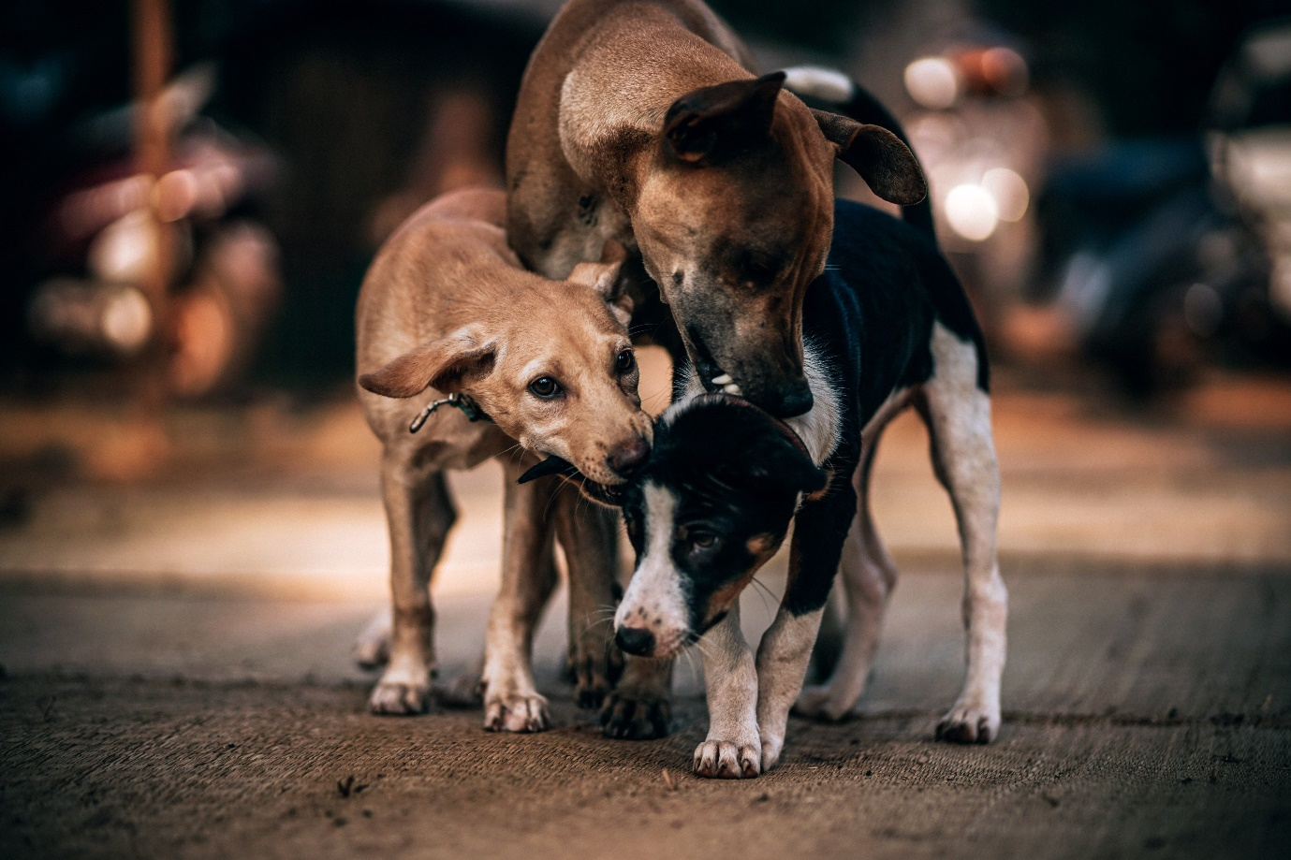

Image for post

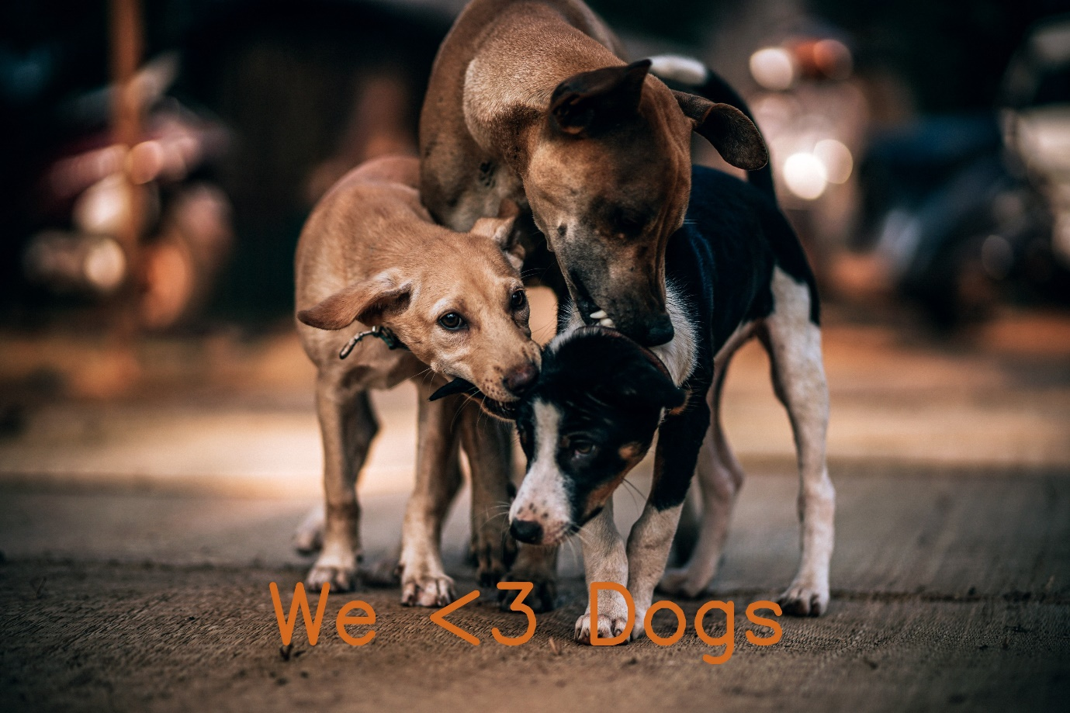

Left: Image from Pexels. Right: Image with text.

import cv2  
output = image.copy()  
cv2.putText(output, "We <3 Dogs", (1500, 3600),cv2.FONT_HERSHEY_SIMPLEX, 15, (30, 105, 210), 40)   
viewImage(output, "image with text")

**The putText function takes 7 parameters**

* The first parameter is the image you want to write on.
* The second parameter is the text itself.
* The third parameter is the *x*, *y*—the bottom left coordinate where the text starts.
* The fourth parameter is the font type.
* The fifth parameter is the font size.
* The sixth parameter is the color (***GBR***/***RGB*** depending on how you imported your image).
* The seventh parameter is the thickness of the text.